INDUSTRY INTERNSHIP REPORT
On
WEB DEVELOPMENT

An internship report submitted in partial fulfillment of
requirements for the award of degree of
BACHELOR OF TECHNOLOGY
COMPUTER SCIENCE AND ENGINEERING

By
Mumman Kotamera Harshita (229X1A05E7)

Under the esteemed guidance of Sri. P. Praveen Yadav Assistant Professor Department of C.S.E.

Department of Computer Science and Engineering
G. PULLA REDDY ENGINEERING COLLEGE (Autonomous): KURNOOL
(Affiliated to JNTUA, ANANTAPURAMU)

2025 - 2026

Department of Computer Science and Engineering
G. PULLA REDDY ENGINEERING COLLEGE (Autonomous): KURNOOL
(Affiliated to JNTUA, ANANTAPURAMU)



CERTIFICATE

This is to certify that the internship titled ‘Plasmid’ is a bonafide record of work carried out by MUMMAN KOTAMERA HARSHITA (229X1A05E7) and the Internship report is submitted in partial fulfillment of requirements for the award of degree of Bachelor of Technology in Computer Science and Engineering.

Sri. P. Praveen Yadav Dr. N. Kasiviswanath
Assistant Professor, Professor and HOD,
Department of C.S.E, Department of C.S.E,
GPREC, Kurnool. GPREC, Kurnool.

INTERNSHIP DETAILS

Name of the College : G. Pulla Reddy Engineering College
Department : Computer Science and Engineering
Name of the Student : Mumman Kotamera Harshita
Register Number : 229X1A05E7
Name of the Faculty Guide : Smt. Susmita Sasmal
Duration of the Internship : From: 15-12-2025 To: 15-03-2026
Name and address of the Organization : Plasmid Innovation of Technologies,1st floor, Featherlight The Address, Marathahalli, Bangalore, KA, 560103
Internship Domain : Web Development
Internship Title : Web Development
Internship Stipend : No Stipend
Date of Internship Report Submission : 18-04-2026

Internship Coordinator
Dr. B. Geetha Vani Professor
CSE Department GPREC

DECLARATION

I Mumman Kotamera Harshita, a student bearing the Roll No. 229X1A05E7, of the Department of Computer Science and Engineering, G. Pulla Reddy Engineering College, do hereby declare that the I have completed the mandatory internship titled Employee Management System using Spring technologies from 15-12-2025 to 15-03-2026 in Plasmid Innovation, Bangalore under the Faculty Guide ship of Smt. Susmita Sasmal

Student Signature and Date

CERTIFICATE FROM ORGANIZATION

This is to certify that Mumman Kotamera Harshita, a student bearing the Roll No. 219X1A05E7 of G. Pulla Reddy Engineering College underwent Internship in Plasmid Innovation from 15-12-2025 to 15-03-2026. The overall performance of the Intern during her internship is found to be good.



Authorized Signatory

INTERNSHIP COMPLETION CERTIFICATE

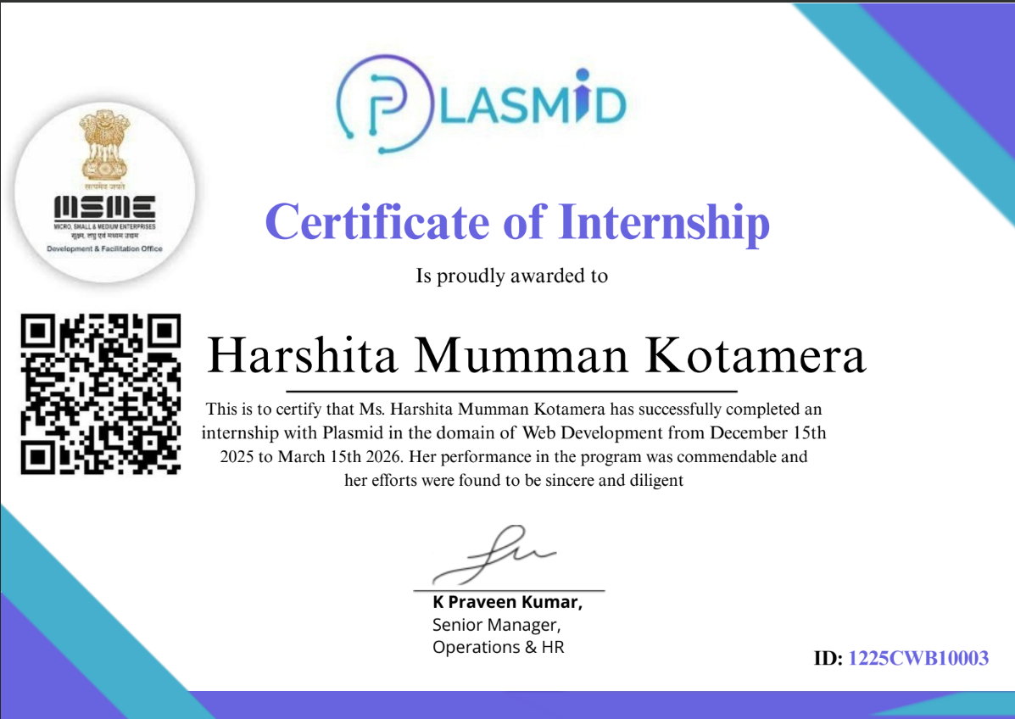

ACKNOWLEDGEMENT

I wish to express my deep sense of gratitude to my internal supervisor Sri. P. Praveen Yadav, Assistant Professor of Computer Science and Engineering Department, G. Pulla Reddy Engineering College.
My sincere thanks to our Internship Coordinator Dr. B. Geetha Vani, Professor of CSE for her immaculate guidance, constant encouragement and cooperation which have made possible to bring out this internship work.
I am thankful to our Head of the Department Dr. N. Kasiviswanath, for his whole hearted support and encouragement during the internship.
We are grateful to our Internship Dean Dr. Y. V. Siva Reddy and to our respected Principal Dr. B. Sreenivasa Reddy for providing requisite facilities and helping us in providing such a good environment.
I wish to convey my acknowledgements to all the staff members of the Computer Science and Engineering Department for giving the required information needed for my internship work.
Finally, I wish to thank all our friends and well-wishers who have helped me directly or indirectly during the course of this internship work.

TABLE OF CONTENTS

CHAPTER Page No
- INTRODUCTION
  - About the Internship Company 10
  - Offline Internship details 11
- WORK DONE DURING INTERNSHIP
  - About Domain 13
  - Technologies learnt during internship 14
- PROJECTS/MODULES COMPLETED
  - Project 1 16
  - Project 2 34
- ACTIVITY LOG 48
- CONCLUSION 50
- REFERENCES 51

LIST OF FIGURES

FIGURE NO. FIGURE NAME PAGE NO.

Figure 3.1.1 Add Department 20
Figure 3.1.1 List Departments 21
Figure 3.1.1 Add Employee 25
Figure 3.1.1 List Employees 26
Figure 3.1.1 About EMI calculator 36
Figure 3.1.1 Donut Chart 37
Figure 3.1.1 History Table 45

INTRODUCTION

About the Internship Company/Organization:

The internship was carried out at Plasmid, a technology-focused training organization dedicated to bridging the gap between academic learning and industry requirements in the field of web development. Plasmid is committed to providing high-quality, structured training through a balanced approach that combines theoretical knowledge with practical, hands-on implementation. The program follows a modern and progressive curriculum that takes students from foundational concepts to advanced full-stack web development skills, ensuring they are industry-ready upon completion.

The training environment at Plasmid is designed to encourage interactive and collaborative learning. Students are guided through live sessions, project-based tasks, and real-world scenarios that help reinforce each concept as it is introduced. The curriculum is carefully structured to build skills incrementally starting from how the internet works, progressing through HTML, CSS, JavaScript, Bootstrap, and Sass, and extending into back-end development with Node.js and database management with SQL.

One of the key strengths of Plasmid's training program is its emphasis on practical application. Rather than limiting learning to theory, every module includes exercises and mini-projects that challenge students to implement what they have learned. This approach develops not only technical proficiency but also problem-solving ability, logical thinking, and the confidence to work on real-world projects independently.

The internship was undertaken within this structured learning environment and culminated in the development of a fully functional EMI Calculator an interactive front-end web application built using HTML, CSS, and JavaScript. This project served as a capstone that brought together all the front-end skills acquired during the training period.

1.2 Offline Internship details:

Training Phase

The internship was carried out at Plasmid, a technology-focused training organization dedicated to excellence in web development education, skill-building, and innovation, with a unique focus on integrating theoretical knowledge with practical implementation. The organization operates with the aim of producing technically competent professionals equipped with strong analytical and creative problem- solving skills.

Since its inception, Plasmid has been committed to providing high-quality education through a balanced approach that combines theoretical knowledge with practical applications. The organization follows a modern and flexible curriculum that emphasizes progressive learning, enabling students to explore diverse domains such as HTML, CSS, JavaScript, Bootstrap, Node.js, and Database Management. This approach ensures that students are not only academically proficient but also industry-ready and capable of addressing complex real-world challenges.

Plasmid's training environment is equipped with structured live sessions, hands-on project assignments, and guided mentorship. These facilities support a wide range of learning activities, allowing students to experiment, innovate, and develop cutting-edge solutions. The organization also promotes a collaborative and interactive learning environment where students actively engage in discussions, assignments, and technical projects, thereby creating opportunities for knowledge exchange and exposure to current industry trends.
One of the key strengths of Plasmid is its strong emphasis on practical application and project-based learning. The organization fosters a skill-driven culture by encouraging students to actively participate in real-world projects, complete assessments, and contribute to building functional web applications.
Various domains are actively covered, including Front-End Development, Back-End Development, Database Management, and Full-Stack Web Technologies.

The Department of Web Development at Plasmid is particularly known for its focus on emerging technologies and modern development methodologies. The curriculum covers fundamental and advanced topics such as HTML5, CSS3, JavaScript, DOM Manipulation, Bootstrap, Sass, jQuery, Node.js, RESTful APIs, and SQL. It also provides opportunities for students to engage in hands-on projects, assessments, and real-time development activities, thereby enhancing their technical expertise and practical understanding.

Program Structure

Duration: 12 weeks

Training Hours: Over 30 hours of instruction

Projects: 2 hands-on projects to apply learned skills
Certification: Industry-recognized certificate upon completion
Mentorship: Guidance from experienced professionals

WORK DONE DURING INTERNSHIP

2.1 About Domain
During my internship, I worked in the domain of Web Development, where I developed real-time web applications using frontend technologies. The internship focused on creating responsive user interfaces, implementing business logic using JavaScript, and building practical applications. Through this internship, I gained hands-on experience in developing interactive web-based tools and understanding real-world application workflows.

Project 1: Employee Management System

Project Description
The Employee Management System is a web-based application developed to manage employee records and department details efficiently. The system allows users to add, update, delete, and view employee information. The application was designed with a user-friendly interface and structured database integration.

Technologies Used
- React
- MySQL
- Spring Boot

Work Done
I designed the frontend interface including forms for adding and updating employee details. Navigation sections were implemented to access different modules of the system. Input validation was added to ensure accurate data entry.
On the backend, CRUD operations were implemented to manage employee records. APIs were used to handle data transfer between frontend and database. The database structure included tables for employees and departments. I tested the system to ensure smooth functionality and fixed errors during development.

This project improved my knowledge in full-stack development, database integration, and application architecture.

Project 2: EMI Calculator

Project Description
The EMI Calculator is a web-based application developed to calculate Equated Monthly Installments (EMI) for loans. The application allows users to enter loan amount, interest rate, and loan tenure, and calculates the monthly EMI instantly. The calculator provides a simple and interactive interface for financial calculations.

Technologies Used
- HTML5
- CSS3
- JavaScript

Work Done
I designed the user interface with input fields for loan amount, interest rate, and tenure. HTML was used to structure the layout, while CSS was applied for styling and responsive design. The layout was designed to be simple and easy to use.
JavaScript was used to implement the EMI calculation logic. Event listeners were added to capture user input and dynamically display the calculated EMI. Input validation was included to handle incorrect values and ensure accurate results.
The application was tested with different loan values to verify correctness. I also added responsive design features so the calculator works properly on mobile and desktop devices. This project helped me understand mathematical calculations in JavaScript and improve my frontend development skills.
2.2 Technologies learnt during internship

Skills Gained During Internship
- Web Application Development
- JavaScript DOM Manipulation
- Responsive Web Design
- CRUD Operations
- Problem Solving
- Debugging and Testing

Tasks Assigned During Internship
- Developed Employee Management System
- Built EMI Calculator using JavaScript
- Implemented responsive UI design
- Tested application functionality
- Debugged errors and improved performance

PROJECTS COMPLETED

3.1 Project – 1: Employee Management System

Abstract

The Employee Management System is a web-based application developed to efficiently manage employee and department details within an organization. The system provides a comprehensive set of functionalities including adding new employees, updating existing records, deleting employee data, and viewing complete employee information through a centralized dashboard.

The primary objective of this project is to eliminate the inefficiencies associated with manual record-keeping by providing a fully automated, structured, and scalable data management solution accessible through a user-friendly web interface. By integrating a relational database backend with a dynamic frontend, the application ensures consistent data storage, rapid information retrieval, and real-time updates, making it a practical and deployable solution for organizations of any size — from small businesses managing a handful of staff to large enterprises maintaining thousands of employee records across multiple departments. The system also enforces data integrity by validating inputs before storage and preventing duplicate or incomplete records from entering the database, thereby maintaining the accuracy and reliability of the information it holds.

Introduction

In any organization, regardless of its scale or industry, the effective management of employee information is a foundational operational requirement. Human Resources departments are routinely responsible for maintaining accurate records of employee identities, contact details, departmental assignments, roles, and employment histories. When this process is handled manually — through spreadsheets, physical registers, or disconnected document files — it becomes not only time-consuming but also highly susceptible to human error. Records become inconsistent across different files, updates made in one location are not reflected in another, and retrieving specific information about a single employee or an entire department can require significant manual effort. These inefficiencies directly impact an organization's ability to make informed decisions about workforce management, payroll processing, and departmental restructuring.

The Employee Management System was developed to overcome precisely these challenges by providing a fully automated, web-based alternative to manual record management. The system enables authorized

administrators to perform all four fundamental data operations — Create, Read, Update, and Delete (CRUD) — on employee records through an intuitive browser-based interface that requires no specialist
technical knowledge to operate. Rather than navigating multiple spreadsheets or manually cross-referencing paper files, an administrator can add a new employee's complete profile in a single form submission, update any field of an existing record with immediate database persistence, remove a departed employee's data with a single action, and retrieve a filtered or complete list of all employees within seconds. All of these operations are backed by a structured relational database that enforces referential integrity and ensures that data relationships — such as the assignment of employees to departments — remain consistent at all times.
Beyond its core data management functionality, the project served as a comprehensive exercise in full-stack web development. The development process encompassed the design and implementation of a relational database schema with appropriately normalized tables for employee and department entities, the construction of a server-side backend to handle HTTP requests, process form data, and execute parameterized database queries, and the creation of a responsive frontend interface with forms, tables, and navigation elements that adapt to different screen sizes. The interaction between these three layers — the browser-based frontend, the server-side application logic, and the persistent database — mirrors the architecture of real-world enterprise web applications, making this project a highly effective vehicle for developing and demonstrating practical full-stack development competency.

The application is organized into four primary functional modules. The Employee Registration module presents an input form for capturing all required employee details — including name, contact information, department assignment, designation, and joining date — and persists the submitted data to the database upon validation. The Employee Update module retrieves an existing employee's current record and pre-populates an editable form, allowing the administrator to modify specific fields and save changes without re-entering unchanged information. The Employee Deletion module allows administrators to permanently remove a selected employee's record from the database, with a confirmation step to prevent accidental deletions. The Employee Directory module displays a paginated, searchable table of all employee records currently stored in the database, with options to filter by department or search by name, allowing administrators to quickly locate specific individuals within large datasets.

Database integration was implemented using a structured schema with separate tables for employees and departments, connected through a foreign key relationship that associates each employee record with a valid department entry. This relational structure ensures that department information is stored once and referenced consistently across all employee records, eliminating redundancy and simplifying department-wide updates. Parameterized queries were used throughout the backend to prevent SQL injection attacks and ensure the security of all database interactions.

This project provided substantial practical exposure to the real-time implementation of web development concepts, deepening understanding of client-server communication through HTTP request-response cycles, server-side form validation and error handling, dynamic HTML generation from database query results, and the principles of relational database design. The development experience bridged the theoretical knowledge of web technologies acquired through coursework with the practical realities of building, testing, and debugging a fully functional multi-page web application — a foundation directly applicable to the more complex AI-driven system developed in this final-year project.

Project Employee Management System:
//Department controller

package net.javaguides.ems.controller;

import lombok.AllArgsConstructor;
import net.javaguides.ems.dto.DepartmentDto;
import net.javaguides.ems.service.DepartmentService; import org.springframework.http.HttpStatus;
import org.springframework.http.ResponseEntity; import org.springframework.web.bind.annotation.*;

import java.util.List;

@CrossOrigin("*") @AllArgsConstructor @RestController @RequestMapping("/api/departments") public class DepartmentController {

private DepartmentService departmentService;

// Build Create or Add Department REST API @PostMapping
public ResponseEntity<DepartmentDto> createDepartment(@RequestBody DepartmentDto departmentDto){
DepartmentDto department = departmentService.createDepartment(departmentDto); return new ResponseEntity<>(department, HttpStatus.CREATED);
}

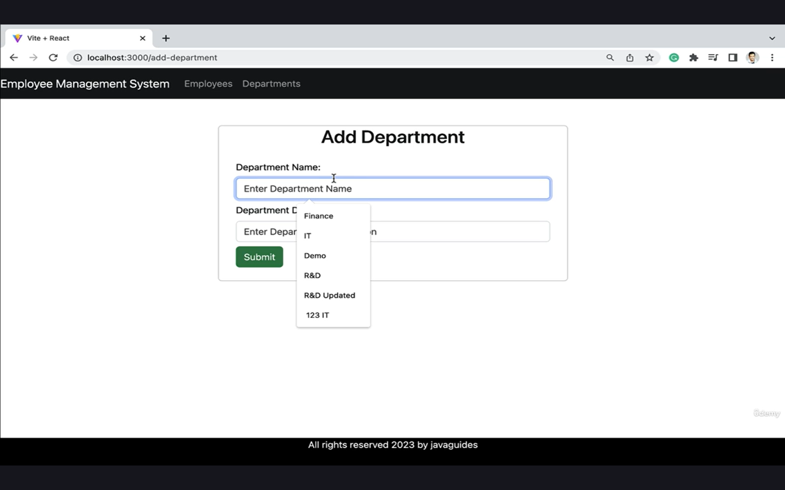

Figure 3.1.1 Adding new Department to the Database
This figure shows the interface used to enter details of a new department into the system. It typically includes fields like department name, ID, and description for data entry.
// Build Get Department REST API

@GetMapping("{id}")
public ResponseEntity<DepartmentDto> getDepartmentById(@PathVariable("id") Long departmentId){
DepartmentDto departmentDto = departmentService.getDepartmentById(departmentId); return ResponseEntity.ok(departmentDto);
}

// Build Get All Departments REST API @GetMapping
public ResponseEntity<List<DepartmentDto>> getAllDepartments(){ List<DepartmentDto> departments = departmentService.getAllDepartments(); return ResponseEntity.ok(departments); }

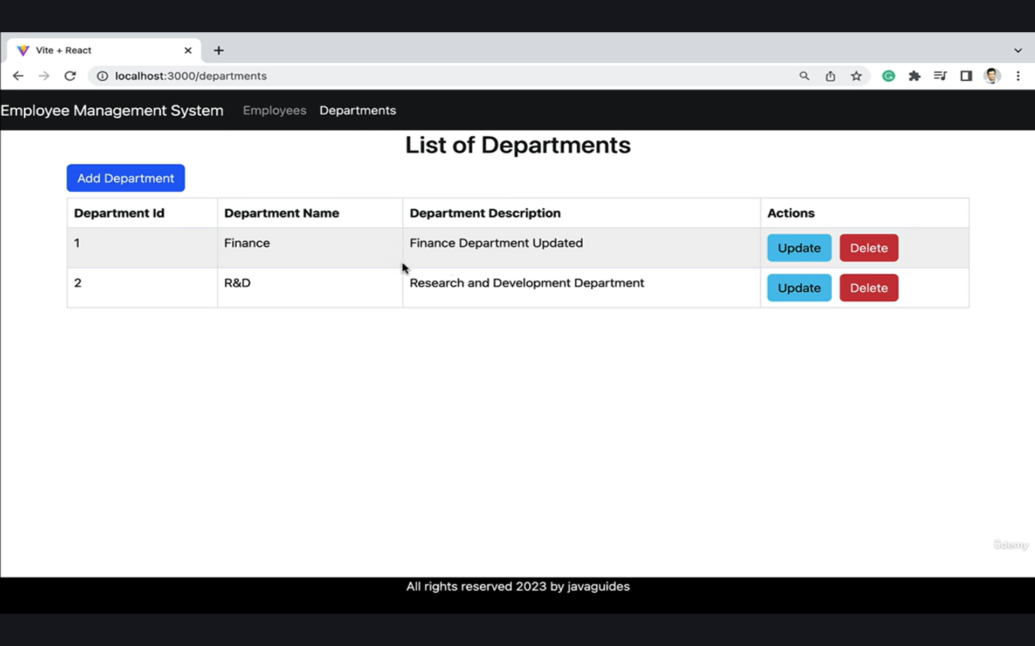

Figure 3.1.2 List of Departments in the Database
This figure displays all departments stored in the database in a tabular format. It helps users view, manage, and verify department records easily.
// Build Update Department REST API @PutMapping("{id}")
public ResponseEntity<DepartmentDto> updateDepartment(@PathVariable("id") Long departmentId,
@RequestBody DepartmentDto updatedDepartment){ DepartmentDto departmentDto = departmentService.updateDepartment(departmentId,
updatedDepartment);
return ResponseEntity.ok(departmentDto);
}

// Build Delete Department REST API @DeleteMapping("{id}")
public ResponseEntity<String> deleteDepartment(@PathVariable("id") Long departmentId){ departmentService.deleteDepartment(departmentId);
return ResponseEntity.ok("Department deleted successfully!.");
}
}

//Department Repository

package net.javaguides.ems.repository;
import net.javaguides.ems.entity.Department;
import org.springframework.data.jpa.repository.JpaRepository;
public interface DepartmentRepository extends JpaRepository<Department, Long> {
}
//Department ServiceImpl

package net.javaguides.ems.service.impl;
import lombok.AllArgsConstructor;
import net.javaguides.ems.dto.DepartmentDto;
import net.javaguides.ems.entity.Department;
import net.javaguides.ems.exception.ResourceNotFoundException;
import net.javaguides.ems.mapper.DepartmentMapper;
import net.javaguides.ems.repository.DepartmentRepository;
import net.javaguides.ems.service.DepartmentService;
import org.springframework.stereotype.Service;
import java.util.List;
import java.util.stream.Collectors;
@Service
@AllArgsConstructor
public class DepartmentServiceImpl implements DepartmentService {
private DepartmentRepository departmentRepository;
@Override
public DepartmentDto createDepartment(DepartmentDto departmentDto) {
Department department = DepartmentMapper.mapToDepartment(departmentDto);
Department savedDepartment = departmentRepository.save(department);
return DepartmentMapper.mapToDepartmentDto(savedDepartment);
}
@Override
public DepartmentDto getDepartmentById(Long departmentId) {
Department department = departmentRepository.findById(departmentId).orElseThrow(
() -> new ResourceNotFoundException("Department is not exists with a given id: " + departmentId)
);
return DepartmentMapper.mapToDepartmentDto(department);
}
@Override
public List<DepartmentDto> getAllDepartments() {
List<Department> departments = departmentRepository.findAll();
return departments.stream().map((department) -> DepartmentMapper.mapToDepartmentDto(department))
.collect(Collectors.toList());
}
@Override
public DepartmentDto updateDepartment(Long departmentId, DepartmentDto updatedDepartment) {
Department department = departmentRepository.findById(departmentId).orElseThrow(
() -> new ResourceNotFoundException("Department is not exists with a given id:"+ departmentId)
);
department.setDepartmentName(updatedDepartment.getDepartmentName());
department.setDepartmentDescription(updatedDepartment.getDepartmentDescription());
Department savedDepartment = departmentRepository.save(department);
return DepartmentMapper.mapToDepartmentDto(savedDepartment);
}
@Override
public void deleteDepartment(Long departmentId) {
departmentRepository.findById(departmentId).orElseThrow(
() -> new ResourceNotFoundException("Department is not exists with a given id: " + departmentId)
);
departmentRepository.deleteById(departmentId);
}
}

//Department Service

package net.javaguides.ems.service;
import net.javaguides.ems.dto.DepartmentDto;
import java.util.List;
public interface DepartmentService {
DepartmentDto createDepartment(DepartmentDto departmentDto);
DepartmentDto getDepartmentById(Long departmentId);
List<DepartmentDto> getAllDepartments();
DepartmentDto updateDepartment(Long departmentId, DepartmentDto updatedDepartment);
void deleteDepartment(Long departmentId);
}

//Employee controller

package net.javaguides.ems.controller;

import lombok.AllArgsConstructor;

import net.javaguides.ems.dto.EmployeeDto;

import net.javaguides.ems.service.EmployeeService;
import org.springframework.http.HttpStatus;
import org.springframework.http.ResponseEntity; import org.springframework.web.bind.annotation.*;
import java.util.List;

@CrossOrigin("*") @AllArgsConstructor @RestController @RequestMapping("/api/employees") public class EmployeeController {
private EmployeeService employeeService;

// Build Add Employee REST API @PostMapping
public ResponseEntity<EmployeeDto> createEmployee(@RequestBody EmployeeDto employeeDto){
EmployeeDto savedEmployee = employeeService.createEmployee(employeeDto); return new ResponseEntity<>(savedEmployee, HttpStatus.CREATED);
}

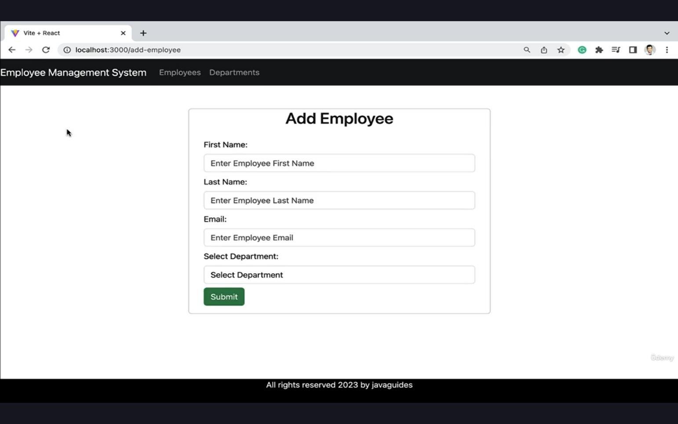
Figure 3.1.3 Adding new Employee to the Database

This figure illustrates the form used to add a new employee’s details. It includes inputs like employee name, ID, department, and other relevant information.

// Build Get Employee REST API @GetMapping("{id}")
public ResponseEntity<EmployeeDto> getEmployeeById(@PathVariable("id") Long employeeId){ EmployeeDto employeeDto = employeeService.getEmployeeById(employeeId);
return ResponseEntity.ok(employeeDto);
}

// Build Get All Employees REST API @GetMapping
public ResponseEntity<List<EmployeeDto>> getAllEmployees(){ List<EmployeeDto> employees = employeeService.getAllEmployees(); return ResponseEntity.ok(employees);

}
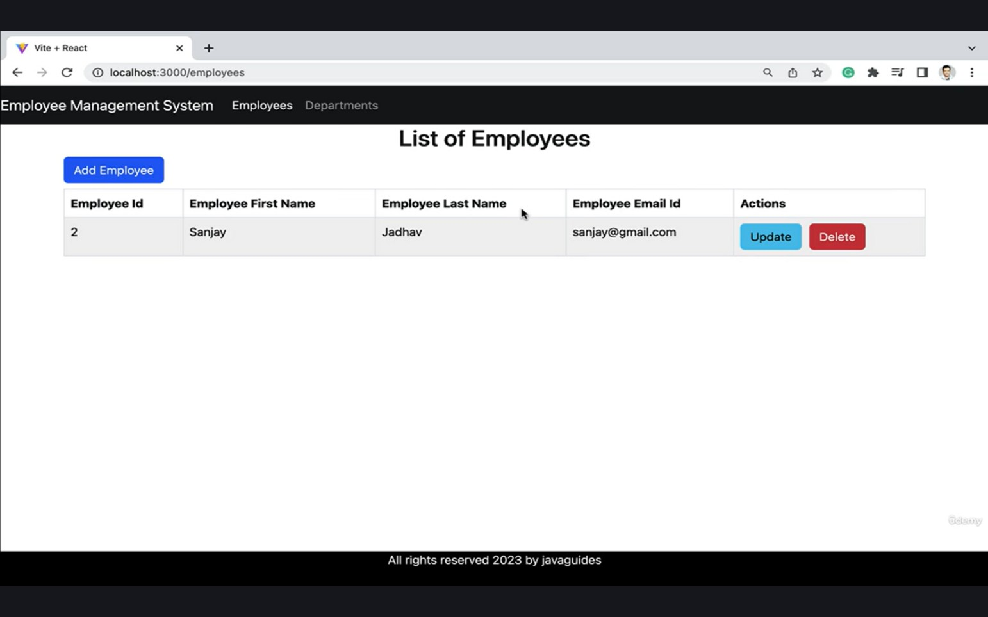

Figure 3.1.4 List all the Employees in the Database

This figure shows a table containing all employee records present in the system. It allows users to review employee details and perform operations like edit or delete.

// Build Update Employee REST API @PutMapping("{id}")
public ResponseEntity<EmployeeDto> updateEmployee(@PathVariable("id") Long employeeId,
@RequestBody EmployeeDto updatedEmployee){
EmployeeDto employeeDto = employeeService.updateEmployee(employeeId, updatedEmployee); return ResponseEntity.ok(employeeDto);
}

// Build Delete Employee REST API @DeleteMapping("{id}")
public ResponseEntity<String> deleteEmployee(@PathVariable("id") Long employeeId){ employeeService.deleteEmployee(employeeId);
return ResponseEntity.ok("Employee deleted successfully!.");
}
}

package net.javaguides.ems.dto;

import lombok.AllArgsConstructor; import lombok.Getter;
import lombok.NoArgsConstructor; import lombok.Setter;

@Getter @Setter
@NoArgsConstructor @AllArgsConstructor
public class DepartmentDto { private Long id;
private String departmentName; private String departmentDescription;
}

package net.javaguides.ems.entity;

import jakarta.persistence.*;
import lombok.AllArgsConstructor; import lombok.Getter;
import lombok.NoArgsConstructor; import lombok.Setter;

@Getter @Setter
@NoArgsConstructor @AllArgsConstructor @Entity
@Table(name = "departments") public class Department {

@Id
@GeneratedValue(strategy = GenerationType.IDENTITY) private Long id;

@Column(name = "department_name") private String departmentName;

@Column(name = "department_description") private String departmentDescription;
}
package net.javaguides.ems.entity;

import jakarta.persistence.*;
import lombok.AllArgsConstructor; import lombok.Getter;
import lombok.NoArgsConstructor; import lombok.Setter;

@Getter @Setter

@NoArgsConstructor @AllArgsConstructor @Entity
@Table(name = "employees") public class Employee {

@Id
@GeneratedValue(strategy = GenerationType.IDENTITY) private Long id;

@Column(name = "first_name") private String firstName;

@Column(name = "last_name") private String lastName;

@Column(name = "email_id", nullable = false, unique = true) private String email;

@ManyToOne(fetch = FetchType.LAZY) @JoinColumn(name = "department_id") private Department department;
}

//Employee Repository
package net.javaguides.ems.repository;
import net.javaguides.ems.entity.Employee;
import org.springframework.data.jpa.repository.JpaRepository;
public interface EmployeeRepository extends JpaRepository<Employee, Long> {
}

//Employee ServiceImpl

package net.javaguides.ems.service.impl;
import lombok.AllArgsConstructor;
import net.javaguides.ems.dto.EmployeeDto;
import net.javaguides.ems.entity.Department;
import net.javaguides.ems.entity.Employee;
import net.javaguides.ems.exception.ResourceNotFoundException;
import net.javaguides.ems.mapper.EmployeeMapper;
import net.javaguides.ems.repository.DepartmentRepository;
import net.javaguides.ems.repository.EmployeeRepository;
import net.javaguides.ems.service.EmployeeService;
import org.springframework.stereotype.Service;
import java.util.List;
import java.util.stream.Collectors;
@Service
@AllArgsConstructor
public class EmployeeServiceImpl implements EmployeeService {
private EmployeeRepository employeeRepository;
private DepartmentRepository departmentRepository;
@Override
public EmployeeDto createEmployee(EmployeeDto employeeDto) {
Employee employee = EmployeeMapper.mapToEmployee(employeeDto);
Department department = departmentRepository.findById(employeeDto.getDepartmentId())
.orElseThrow(() ->
new ResourceNotFoundException("Department is not exists with id: " + employeeDto.getDepartmentId()));
employee.setDepartment(department);
Employee savedEmployee = employeeRepository.save(employee);
return EmployeeMapper.mapToEmployeeDto(savedEmployee);
}
@Override
public EmployeeDto getEmployeeById(Long employeeId) {
Employee employee = employeeRepository.findById(employeeId)
.orElseThrow(() ->
new ResourceNotFoundException("Employee is not exists with given id : " + employeeId));
return EmployeeMapper.mapToEmployeeDto(employee);
}
@Override
public List<EmployeeDto> getAllEmployees() {
List<Employee> employees = employeeRepository.findAll();
return employees.stream().map((employee) -> EmployeeMapper.mapToEmployeeDto(employee))
.collect(Collectors.toList());
}
@Override
public EmployeeDto updateEmployee(Long employeeId, EmployeeDto updatedEmployee) {
Employee employee = employeeRepository.findById(employeeId).orElseThrow(
() -> new ResourceNotFoundException("Employee is not exists with given id: " + employeeId)
);
employee.setFirstName(updatedEmployee.getFirstName());
employee.setLastName(updatedEmployee.getLastName());
employee.setEmail(updatedEmployee.getEmail());

Department department = departmentRepository.findById(updatedEmployee.getDepartmentId())
.orElseThrow(() ->
new ResourceNotFoundException("Department is not exists with id: " + updatedEmployee.getDepartmentId()));
employee.setDepartment(department);
Employee updatedEmployeeObj = employeeRepository.save(employee);
return EmployeeMapper.mapToEmployeeDto(updatedEmployeeObj);
}
@Override
public void deleteEmployee(Long employeeId) {
Employee employee = employeeRepository.findById(employeeId).orElseThrow(
() -> new ResourceNotFoundException("Employee is not exists with given id: " + employeeId)
);
employeeRepository.deleteById(employeeId);
}
}

//Employee Service

package net.javaguides.ems.service;
import net.javaguides.ems.dto.EmployeeDto;
import java.util.List;

public interface EmployeeService {
EmployeeDto createEmployee(EmployeeDto employeeDto);
EmployeeDto getEmployeeById(Long employeeId);
List<EmployeeDto> getAllEmployees();
EmployeeDto updateEmployee(Long employeeId, EmployeeDto updatedEmployee);
void deleteEmployee(Long employeeId);
}

3.2 Project – 2: EMI Calculator

Abstract

The EMI Calculator is a web-based financial application developed to simplify and automate the process of calculating the Equated Monthly Installment (EMI) for various types of loans, including home loans, personal loans, vehicle loans, and education loans. In today's financial landscape, borrowers are frequently required to make informed decisions about loan affordability before committing to a repayment plan, yet the mathematical formula underlying EMI computation involves compound interest principles that are non-trivial to evaluate manually. This project addresses that challenge by delivering an intuitive, browser-based tool that eliminates the need for manual calculation entirely.

The application accepts three primary financial inputs from the user: the principal loan amount, the annual interest rate, and the loan repayment tenure expressed in months or years. Upon submission, the system instantly applies the standard EMI formula — EMI = [P × R × (1+R)^N] / [(1+R)^N – 1], where P is the principal, R is the monthly interest rate, and N is the total number of monthly installments — and displays the computed EMI value in real time without requiring any page refresh. In addition to the monthly installment figure, the application also presents the total amount payable over the full loan tenure and the total interest component, giving users a comprehensive financial summary that supports more informed borrowing decisions.

The application is built entirely using core front-end web technologies: HTML5 for the structural markup of the interface, CSS3 for visual styling and responsive layout design, and JavaScript for all calculation logic, input validation, and dynamic DOM manipulation. Input validation routines are implemented in JavaScript to detect and reject invalid entries such as negative values, zero principal amounts, or non-numeric characters, ensuring that the calculation engine always operates on well-formed data. The interface dynamically updates all output fields in response to user inputs, providing a seamless and responsive experience across both desktop and mobile browsers without requiring any back-end server, database, or external API dependency.

This project demonstrates the practical application of mathematical computation within a browser environment, reinforces core concepts of front-end web development including event handling, DOM manipulation, and form validation, and produces a functional financial tool with genuine real-world utility for students, working professionals, and prospective borrowers seeking to plan their loan repayments effectively.

Introduction

Managing personal finances effectively requires a clear understanding of loan repayment obligations before a borrowing commitment is made. One of the most fundamental metrics in loan planning is the Equated Monthly Installment — a fixed payment amount made by a borrower to a lender on a specified date each calendar month. The EMI consists of two components: a portion that repays the principal borrowed and a portion that covers the interest accrued on the outstanding balance. Because the interest is compounded monthly and the outstanding principal decreases with each payment, the precise EMI value for any given combination of loan amount, interest rate, and tenure cannot be easily determined through simple arithmetic. The standard EMI formula involves exponential terms that, when applied manually, are highly susceptible to computational error and require considerable time even for financially literate individuals.

The EMI Calculator project was conceived and developed to eliminate this barrier entirely. By encoding the EMI formula in JavaScript and embedding it within an interactive web interface, the application allows any user — regardless of their mathematical background — to obtain an accurate EMI estimate within seconds of entering their loan details. The user experience is designed to be as frictionless as possible: the interface presents three clearly labeled input fields, a single calculation trigger, and an organized output section that displays not just the monthly installment but the full financial picture including total repayment amount and total interest cost.

The project is implemented using a purely front-end technology stack consisting of HTML5, CSS3, and JavaScript, making it entirely self-contained and deployable without any server-side infrastructure. HTML5 provides the semantic structure of the web page, defining the input form, output containers, and layout hierarchy. CSS3 governs the visual presentation of the application, including typography, color scheme, spacing, border styling, and responsive layout rules that ensure the interface renders correctly on screens of varying sizes from mobile phones to desktop monitors. JavaScript serves as the computational and behavioral engine of the application, implementing the EMI formula, handling user interaction events, performing input validation, and dynamically updating the output fields in the browser's Document Object Model (DOM) without triggering a full page reload.

A key design consideration in the development of this project was the implementation of robust input validation. Financial calculators are only useful if their inputs are meaningful, and unvalidated inputs such as a loan amount of zero, a negative interest rate, or an alphabetic character in a numeric field would produce either mathematically undefined results or misleading outputs. The validation logic implemented in JavaScript checks each input field for completeness, numeric type, and acceptable value ranges before the calculation is permitted to proceed, and displays descriptive error messages that guide the user toward correcting their input.

From an educational standpoint, this project provided practical experience in several important areas of front-end web development: translating a mathematical formula into programmatic logic using JavaScript arithmetic operators and the Math.pow() function, managing user interface state through DOM manipulation using document.getElementById() and innerHTML updates, implementing event-driven programming through button click handlers and input change listeners, and applying CSS styling principles to create a visually clean and professional interface. The project also deepened understanding of the financial mathematics underlying loan amortization, providing context for why the EMI formula takes the form it does and how changes in each input parameter affect the monthly payment and total interest burden. Together, these technical and conceptual learnings make the EMI Calculator project a meaningful and well-rounded exercise in practical web application development.

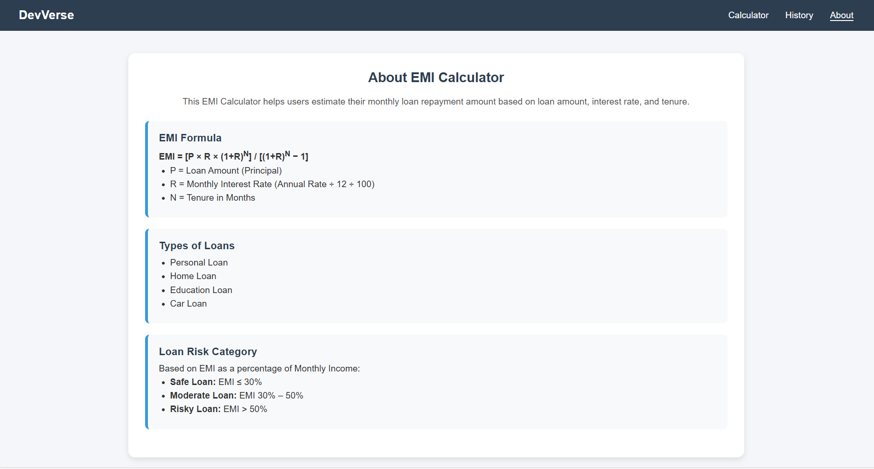

Figure 3.2.1 About EMI calculator
This figure provides an overview of the EMI calculator feature and its purpose.
It explains how users can calculate loan installments based on inputs like amount, interest, and tenure.

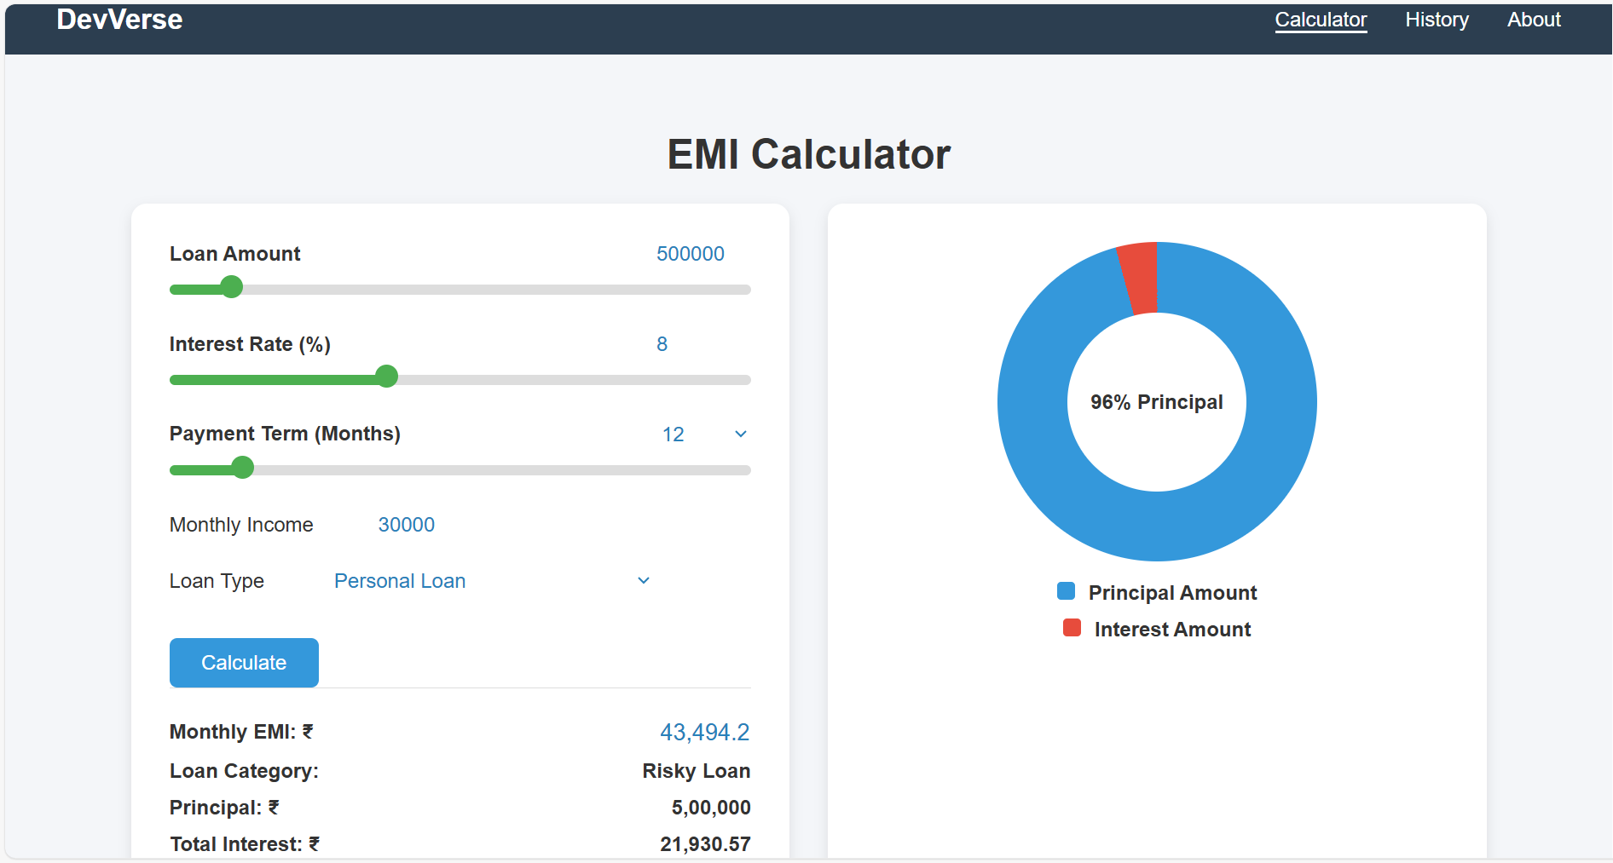

Figure 3.2.2 EMI calculator with donut chart for readability

This figure shows the EMI results along with a donut chart visualization. The chart improves understanding by clearly showing the principal and interest breakdown.

Code Implementation: Project EMI Calculator:
const loanAmountInput = document.getElementById('loanAmount');
const interestRateInput = document.getElementById('interestRate');
const tenureInput = document.getElementById('tenure');

const loanAmountDisplay = document.getElementById('loanAmountDisplay');
const interestRateDisplay = document.getElementById('interestRateDisplay');
const tenureDisplay = document.getElementById('tenureDisplay');

const incomeInput = document.getElementById('income');
const loanTypeSelect = document.getElementById('loanType');

const monthlyEMIDisplay = document.getElementById('monthlyEMI');
const principalAmountDisplay = document.getElementById('principalAmount');
const totalInterestDisplay = document.getElementById('totalInterest');
const loanCategoryDisplay = document.getElementById('loanCategory');

const chart = document.getElementById("emiChart");
const chartCenter = document.getElementById("chartCenter");
const historyBody = document.getElementById("historyBody");

const tabCalculator = document.getElementById("tabCalculator");
const tabHistory = document.getElementById("tabHistory");
const tabAbout = document.getElementById("tabAbout");

const calculatorSection = document.getElementById("emicalculator");
const historySection = document.getElementById("history");
const aboutSection = document.getElementById("about");

let lastCalculatedData = null;

/* ------------------ Populate Tenure Dropdown ------------------ */
for (let i = 6; i <= 60; i++) {
const option = document.createElement("option");
option.value = i;
option.textContent = i;
tenureDisplay.appendChild(option);
}
tenureDisplay.value = tenureInput.value;

/* ------------------ TAB SWITCH ------------------ */
tabCalculator.onclick = (e) => { e.preventDefault(); showCalculator(); };
tabHistory.onclick = (e) => { e.preventDefault(); showHistory(); };
tabAbout.onclick = (e) => { e.preventDefault(); showAbout(); };

function showCalculator() {
calculatorSection.classList.add("active");
historySection.classList.remove("active");
aboutSection.classList.remove("active");

tabCalculator.classList.add("active");
tabHistory.classList.remove("active");
tabAbout.classList.remove("active");
}

function showHistory() {
historySection.classList.add("active");
calculatorSection.classList.remove("active");
aboutSection.classList.remove("active");

tabHistory.classList.add("active");
tabCalculator.classList.remove("active");
tabAbout.classList.remove("active");
}

function showAbout() {
aboutSection.classList.add("active");
calculatorSection.classList.remove("active");
historySection.classList.remove("active");

tabAbout.classList.add("active");
tabCalculator.classList.remove("active");
tabHistory.classList.remove("active");
}

/* ------------------ SLIDER SYNC ------------------ */
function updateSliderFill(slider) {
const value = (slider.value - slider.min) / (slider.max - slider.min) * 100;
slider.style.background =
`linear-gradient(to right, #4CAF50 ${value}%, #ddd ${value}%)`;
}

function sync(range, number) {

// When slider moves → update number field
range.addEventListener("input", () => {
number.value = range.value;
updateSliderFill(range);
});

// When typing → update slider (without forcing min/max immediately)
number.addEventListener("input", () => {
const val = parseFloat(number.value);

if (!isNaN(val)) {
range.value = val;
updateSliderFill(range);
}
});

// When user leaves input field → enforce limits
number.addEventListener("blur", () => {
let val = parseFloat(number.value);

if (isNaN(val)) val = parseFloat(range.min);

if (val < parseFloat(range.min)) val = parseFloat(range.min);
if (val > parseFloat(range.max)) val = parseFloat(range.max);

number.value = val;
range.value = val;
updateSliderFill(range);
});

updateSliderFill(range);
}

sync(loanAmountInput, loanAmountDisplay);
sync(interestRateInput, interestRateDisplay);

tenureInput.oninput = () => {
tenureDisplay.value = tenureInput.value;
updateSliderFill(tenureInput);
};

tenureDisplay.onchange = () => {
tenureInput.value = tenureDisplay.value;
updateSliderFill(tenureInput);
};

updateSliderFill(tenureInput);

/* ------------------ CALCULATE EMI ------------------ */
document.getElementById("calculateBtn").onclick = calculateEMI;

function calculateEMI() {

const P = parseFloat(loanAmountInput.value);
const rate = parseFloat(interestRateInput.value);
const months = parseInt(tenureInput.value);
const income = parseFloat(incomeInput.value);

// Validation
if (isNaN(P) || P <= 0) {
alert("Enter valid Loan Amount");
return;
}

if (isNaN(rate) || rate <= 0) {
alert("Interest rate must be greater than 0");
return;
}

if (isNaN(months) || months < 6) {
alert("Tenure must be at least 6 months");
return;
}

if (isNaN(income) || income <= 0) {
alert("Enter valid Monthly Income");
return;
}
const r = rate / 12 / 100;

let emi;
if (r === 0) {
emi = P / months;
}
else {
emi = (P * r * Math.pow(1 + r, months)) /
(Math.pow(1 + r, months) - 1);
}

if (!isFinite(emi)) {
alert("Calculation error. Check inputs.");
return;
}

const total = emi * months;
const interest = total - P;

monthlyEMIDisplay.value =
Number(emi.toFixed(2)).toLocaleString('en-IN');

principalAmountDisplay.textContent =
P.toLocaleString('en-IN');

totalInterestDisplay.textContent =
Number(interest.toFixed(2)).toLocaleString('en-IN');

/* ----- Loan Category ----- */
const emiPercent = (emi / income) * 100;

let category;
if (emiPercent <= 30) category = "Safe Loan";
else if (emiPercent <= 50) category = "Moderate Loan";
else category = "Risky Loan";

loanCategoryDisplay.textContent = category;

drawChart(P, interest);

lastCalculatedData = {
loan: P.toLocaleString('en-IN'),
rate: rate,
months: months,
income: income.toLocaleString('en-IN'),
type: loanTypeSelect.value,
emi: monthlyEMIDisplay.value,
category: category
};
}

/* ------------------ CHART ------------------ */
function drawChart(principal, interest) {
const total = principal + interest;
const angle = (principal / total) * 360;

chart.style.background = `conic-gradient(
#3498db 0deg,
#3498db ${angle}deg,
#e74c3c ${angle}deg,
#e74c3c 360deg
);

chartCenter.textContent =
Math.round((principal / total) * 100) + "% Principal";
}

/* ------------------ SAVE HISTORY ------------------ */
document.getElementById("save").onclick = () => {

if (!lastCalculatedData) {
alert("Please calculate EMI before saving.");
return;
}

let historyData =
JSON.parse(localStorage.getItem("emiHistory")) || [];

historyData.push(lastCalculatedData);

localStorage.setItem(
"emiHistory",
JSON.stringify(historyData)
);

addRow(lastCalculatedData);
showHistory();
};

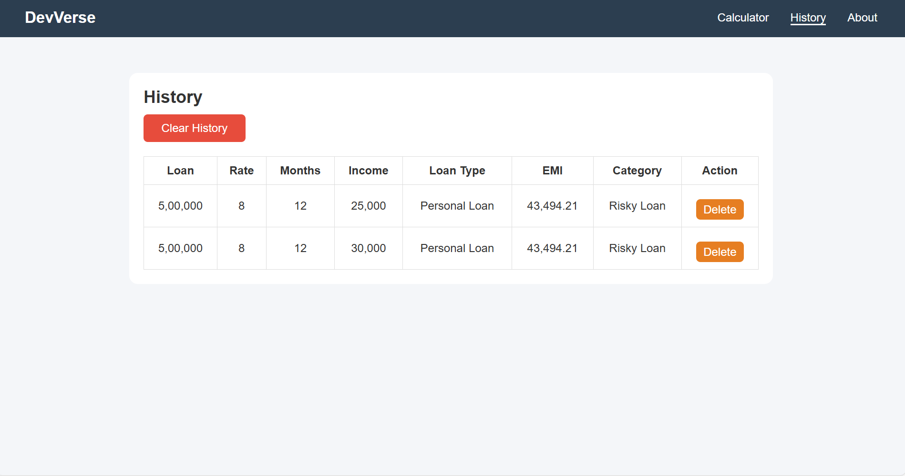

Figure 3.2.3 History table to view all the previous calculations

This figure displays a history table of all past EMI calculations. It helps users track and compare their previous loan computations easily.

/* ------------------ LOAD HISTORY ------------------ */
window.onload = () => {
const historyData =
JSON.parse(localStorage.getItem("emiHistory")) || [];

historyData.forEach(addRow);
};

function addRow(item) {

const row = document.createElement("tr");

row.innerHTML = `

<td>${item.loan}</td>
<td>${item.rate}</td>
<td>${item.months}</td>
<td>${item.income}</td>

<td>${item.type}</td>
<td>${item.emi}</td>
<td>${item.category}</td>
<td><button class="delete-btn">Delete</button></td>
row.querySelector(".delete-btn").onclick = () => {
row.remove();
updateStorage();
};

historyBody.appendChild(row);
}

document.getElementById("clearHistory").onclick = () => {
historyBody.innerHTML = "";
localStorage.removeItem("emiHistory");
};

function updateStorage() {

const rows = historyBody.querySelectorAll("tr");
let data = [];

rows.forEach(r => {
const c = r.querySelectorAll("td");
data.push({

loan: c[0].textContent,
rate: c[1].textContent,
months: c[2].textContent,
income: c[3].textContent,
type: c[4].textContent,
emi: c[5].textContent,
category: c[6].textContent
});
});

localStorage.setItem("emiHistory", JSON.stringify(data));
}

- ACTIVITY LOG FOR THE WEEK

Weeks | Description of the weekly activity | Learning Outcome | Person  In charge Signature
Week 1 | Attended internship orientation session, understood organization workflow, discussed project guidelines, and installed required software such as code editor and browser tools. | Gained understanding of internship objectives, development environment setup, and basic workflow of web development projects.
Week 2 | Learned HTML fundamentals including tags, forms, tables, and semantic elements. Created basic static web pages for practice. | Acquired knowledge of HTML structure and ability to design simple webpages.
Week 3 | Studied advanced HTML5 concepts, semantic elements, and form controls. Started designing sample web layouts. | Learned advanced HTML concepts and improved page structuring skills.
Week 4 | Learned CSS fundamentals including selectors, box model, layout, background, text styling, and animations. | Acquired skills in styling webpages using CSS.
Week 5 | Studied CSS Grid and layout design. Introduction to Bootstrap and created responsive layouts using Bootstrap components. | Learned responsive design and layout management.
Week 6 | Created sample portfolio webpage with header, footer, hero section, and responsive design using Bootstrap. | Gained experience in building responsive web pages.

Weeks | Description of the weekly activity | Learning Outcome | Person  In charge  Signature
Week 7 | Introduction to JavaScript, variables, data types, operators, control statements, and basic calculator implementation. | Learned JavaScript fundamentals and logic building.
Week 8 | Studied functions, arrays, objects, loops, and DOM manipulation. Implemented interactive elements using JavaScript. | Improved DOM manipulation and dynamic webpage development skills.
Week 9 | Learned JavaScript OOP concepts, constructors, inheritance, and events handling. Worked on background generator exercise. | Gained knowledge of advanced JavaScript concepts.
Week 10 | Introduction to jQuery and Node.js. Learned modules, Express framework, and RESTful APIs. | Understood backend basics and server-side development.
Week 11 | Studied Database and SQL concepts including create table, insert, update, delete, and join operations. | Learned database management and SQL queries.
Week 12 | Major project discussion and development of Employee Management System and EMI Calculator. Final testing and documentation preparation. | Gained practical experience in real-time project development and documentation.

CONCLUSION

During the internship, I successfully completed two projects: Employee Management System and EMI Calculator. These projects helped me apply the concepts learned during the training in a practical manner. While working on the Employee Management System, I gained experience in designing user interfaces, implementing CRUD operations, and managing employee data efficiently. This project improved my understanding of structured web application development and responsive design.
The EMI Calculator project helped me implement mathematical logic using JavaScript and develop an interactive user interface. I learned how to handle user inputs, perform dynamic calculations, and display results in real time. This project enhanced my skills in DOM manipulation and frontend development.
Overall, working on these two projects improved my technical knowledge, problem-solving ability, and debugging skills. The internship provided hands-on experience in web development and helped me understand real-time project implementation. It also increased my confidence in developing user-friendly and responsive web applications.

REFERENCES

- https://spring.io/projects/spring-boot
- https://spring.io/projects/spring-data-jpa
- https://react.dev
- https://dev.mysql.com/doc
- https://developer.mozilla.org/en-US/docs/Web/JavaScript
- https://projectlombok.org
- https://restfulapi.net
- https://www.w3schools.com
- Walls, C., Spring in Action, Manning Publications, 6th Edition, 2022.
- Horstmann, C. S., Core Java Volume I – Fundamentals, Pearson Education, 12th Edition, 2021.
- Flanagan, D., JavaScript: The Definitive Guide, O'Reilly Media, 7th Edition, 2020.
- Duckett, J., HTML and CSS: Design and Build Websites, John Wiley & Sons, 2011.

